*Please share these dates and package with everyone - team members and family and friend spectators.*  [join our Facebook page “BayouDeSiardDragonBoatFestival” to receive info & reminders about all event activities.](https://www.facebook.com/BayouDesiardDragonBoatFestival/)

**DRAGON BOAT FESTIVAL**

**Saturday May 12th FESTIVAL DAY:**@ corner of Loop Rd. and Forsythe Rd.

**10:00 AM**  
**Community Health Fair** (ends at 2 PM)  
& **Team Members check-in** @ the Welcome Tent to get Participant Wristbands **(mandatory**)

**10:15 AM**  
**All Captain’s Meeting at the Dock (mandatory**)

**10:40 AM**

**Team Members set up for Team Parade**

**11:00 AM**

**Opening Ceremony & Team Parade**  
  
**12:00 PM**

**Races begin  
  
5:00 PM  
Closing Ceremony, Race Awards & tent and Event breakdown**

**PRE-FESTIVAL ACTIVITIES:**

**Free activities for anyone interested:  
TEAM RALLY @ Flying Tiger Brewer  
Wednesdays: February 21, March 21, April 25   
4:30-8 PM**  
 **Dry-Land Boot Camp @ InFit Gym Monroe  
Saturdays: March 24, May 5  
1:00-200 PM**

**Yoga @ Blue Sky Yoga Monroe  
Saturdays: March 17, April 21  
1:00-200 PM**

**Activities for Teams only:**

**March - May**  
**TEAM DRY-LAND PRACTICES**

**Tues-Thurs, May 9-11  
5:15 PM, 6:15 PM, 7:15 PM (1 hour)**

**TEAM WATER PRACTICES (mandatory)**

**@ the dock at Bayou DeSiard Country Club**

**For Teams and Registered Runners:**

**Friday May 12, 5-10 PM**

**DOTTING OF THE EYE PARTY & Fleet Feet Draggin’ Tail Fun Run @ the festival area  
(optional team tent set up & early Wristband check-in)**

**SPONSORED BY:   **

Keep reading, we have good information here…

LAUNCH PARTY & TEAM RALLY’S @ Flying Tiger Brewery

* The fun starts now! Invite your colleagues, friends and family (21 years or older) to join us for a fun night out.
* Get to know your team or recruit some members. Sign up and sponsorship information will be available.
* Team captains are especially encouraged to attend to get one-on-one information.
* Special beer and drinks will be available for sale.

PRACTICES:

***Water Practice***

* Water practice will take place in the evenings the week of the festival, Thu-Thus May 9 –11.
* Each team will have the opportunity to practice one time for one hour.
* Practice races take place on the dock of the Bayou DeSiard Country Club, across the bayou of the festival site.
* **TEAM’S PAYMENT MUST BE PAID IN FULL BEFORE YOUR TEAM CAN PRACTICE OR BE INCLUDED IN THE EVENT**.
* **Captains (only) sign up for you team’s practice with the link below –**[www.SignUpGenius.com/go/30E044AAEAC2AAAF85-2018](http://www.signupgenius.com/go/30E044AAEAC2AAAF85-2018)

***Dry-Land Practice***

* Dry-Land early training practice is for one hour and a private training at your business location.
* Organized by InFit Fitness. **Captains call to schedule your appointment, (318) 381-8287**.
* Don’t worry about have the final rowers for your team; it is ok to include everyone interested.

MAY 11, FRIDAY NIGHT:

***Event Location*** - This is an overview of the festival area, on the corner of Loop Road and Forsythe. Loop Road will be blocked off between Forsythe and Westminster. Practices will be on the DeSiard Country Club side of Bayou DeSiard.

***Friday Night Pre-Party*** “**Dotting of the Eye Ceremony**

* Private party for all team members and managers/owners, sponsors, and Draggin’ Tail Fun Run VIP Pass holders.
* This is a good time to set up your team tent and member check in to get their participation wrist band early. (Overnight security will help look over things you bring)
* Party festivities include: ceremonial dotting of the eye, live music, food and adult drinks, food trucks and more.
* Race times and heats will be revealed at the party.

***Festival Day Team Tent Area*** – Each team area is 15’ x 15’ which will accommodate a tent (tent provided by each team).

* These tents can be set up on Friday May 11 at 5:00pm or Saturday May 12 between 8am-9:30am.
* Lawn or street spaces are first come first serve. Only sponsors have designated tent areas. Refer to the map for the exact area.

Teams are encouraged to bring chairs, blankets, towels, etc. and to decorate their tent in their team theme. Corporate displays are welcome. There will be no grilling or open flames in the team area and no team will have access to power. Team area, including tent, chairs and trash, must be removed from the festival area by 6 PM. Please bring and wear sunscreen!

***Fleet Feet Draggin’ Tail Fun Run –*** Ages 15 and up can sign up for this 5K race. Online sign up and pricing information is at [https://legacy.imathlete.com/events/draggintail](https://www.google.com/url?q=https%3A%2F%2Flegacy.imathlete.com%2Fevents%2Fdraggintail&sa=D&usd=2&usg=AFQjCNEQczBS5v6YcEVZzzzB3m1lXM2Q2A) or visit the Fleet Feet store.

May 12, Festival day:

***Health Fair*** – Free for families and children to visit booths, join in on exercise demonstrations, and learn about local health services in our community.

***Spectator Area*** – Spectators are encouraged to watch the races from this area. No recreational swimming will be allowed in the bayou during the event.

***Team Themes*** – Teams are encouraged to have a name, theme, and can dress alike. The drummer can dress in any sort of costume to match that theme. (Points will be given for Team Spirit!)

***Awards***– The top teams will earn awards for 1. team spirit, 2. best dressed teams, 3. race heats category perennial cups and 4. final race-off for the perennial trophy. Teams are encouraged to have a theme, and the drummer can dress in any sort of costume to match that theme. See our Facebook photos for ideas.

***Food*** – Participants and spectators can purchase food and drinks from participating food truck vendors.

***Festival T-Shirt*** – Event t-shirts will be available for sale at practices and the Festival.

**Notice of Delays or Cancellation -** Weather concerns may cause delays or cancellation. Event coordinators and 22Dragons, the racing management company, have the discretion to delay or cancel the event due to lightning, heavy rain, hail, or high winds. No participants will be allowed on the water in lightning conditions. Safety must come first, 22Dragons uphold a zero-tolerance policy for safety.

RULES FOR RACING

***General -*** The dragon boat races shall be under the supervision and control of the Chief Race Official who shall retain authority over all matters related to racing. The Chief Race Official will lead the team captains meeting and will answer all questions before racing begins.

***Team Composition***

* All crews must provide their own drummer. Participation in the "best dressed drummer contest" is highly encouraged but not mandatory.
* The maximum number of paddlers for any crew is 20.
* The minimum for any crew is 12 paddlers, a drummer and a steersperson.
* The minimum age for a participant is 12 years old.
* All crews will be provided a steersperson by 22Dragons.

*“Strength lies in differences, not in similarities.” Stephen R. Covey*

The Bayou DeSiard Dragon Boat Festival is a family-friendly and action packed fundraising event. Ultimately, the winners are children and their families in our community who gain financial support from the boat teams and sponsors who participate and help raise money. For team composition, we encourage teams to include rowers with a range of ages (14+), athletic abilities and gender. Inclusiveness is a valuable mindset and it can bolster your dragon boat team’s composition for the races. One of the best benefits for an organization or business to be on a boat together is to have the opportunity to gain team-building experiences and skills.

There are 2 things you should know about how a diverse rowing team can best be positioned in the boat:

1.       All boats will have a professional steersperson. You will meet our steerspersons, from 22 Dragons, at the water practice. The steersperson has the knowledge of how to arrange rowers to improve the balance of the boat. The steersperson is responsible for the safety of your team.

2.      A boat should be balanced side-to-side and front-to-back. Think about the dragon boat divide into three sections, front, middle, back, with a drummer at the front edge of the boat.

* The front has six rowers, 3 side-by-side in pairs

At the front of the boat, the water is still. It requires big strokes to get the water to move across the boat. It is best to have people with longer arms and flexibility up front.  Lighter weight rowers are also ideal to have in the font. This section of rowers helps set the pace for the rest of the team.

* The middle has eight rowers, 4 sided-by-side in pairs

The water rushes to the middle section of the boat and begins to get choppy. It is best to have the stronger rowers here. Also, for weight distribution, heavier rowers do best in this section.

* The back has six rowers, 3 side-by-side in pairs

At the back of the boat, the water is moving the quickest and the choppiest. Here is where the quickest bursts of power are needed. The strongest rowers with shorter arms can maneuver best with these waters and speed. Shorter and more powerful strokes can help advance the boat.

* The single drummer sits up front on the edge of the boat, faces the team and beats the drum to help the team row in rhythm

Anyone who wants to help lead team in unity will be well suited as the drummer. It is good for this person to give encouragement and maintain positive energy and excitement for the team. Keeping the team on rhythm with the beat of the drum will be most important during race time.

***Race progression -*** All teams will race in two heats during the festival. Teams will be organized into groups to compete for a perennial category cup. Then, the fastest 6 teams from the heats will be entered into a final race-off. The fastest time will win the perennial trophy.

The starting procedure shall be "All Paddlers Ready", followed by “Attention Please”, followed by a shot or air horn. Any team caught false starting will receive a 2 second penalty.

All crews must remain in their lane for the duration of the race. Leaving your lane may result in a 2 second penalty at the discretion of the chief race official.

***Safety -*** All participants must wear a certified PFD (Personal Flotation device). PFD's will be provided, individuals may use their own PFD's so long as it is US Coast Guard Approved, inflatable PFD's are not allowed.

All participants are strongly discouraged from taking any kind of valuable or electronic device on board with them as there is a possibility of these items getting wet from paddling or during capsize.

Unless absolutely necessary and under the control of the coach, it is strictly forbidden for a paddler to stand up in the boat for risk of capsizing (especially at the finish of a race)

All participants must sign a waiver form before being allowed to practice or race. The waiver of a participant under the age of 18 must be signed by a Parent or Guardian. It is the captain’s responsibility to ensure that all participants in his or her crew have signed a waiver form. Any paddler caught racing who has not signed a waiver form risks the disqualification of his or her crew from the race.

Capsizing is extremely rare but there is a possibility that it could happen. Observing the following safety guidelines will ensure the safety of all participants

Before getting in the boat, each paddler must identify their buddy. Their buddy is their seat partner. The drummer will buddy with the two strokers (first seat), and the steersperson with the last two paddlers. In the event of a boat capsizing all paddlers are to remain calm, check that their buddy is ok, remain with the boat, and wait for instructions from the safety boat.

The safety boat that will make sure that everyone is present and check for anyone that needs immediate medical attention.

Once the safety boat has guaranteed that everyone is ok they will begin retrieving participants.

***Etiquette -*** All participants are expected to treat the officials, organizers, volunteers, their fellow competitors and spectators with respect. Any abuse of this fact witnessed during the festival is to be reported to the organizing committee who will review the situation and take appropriate action that may include expulsion of a participant or crew from the festival.

All crews are expected to respect the rules and regulations of racing and the judgment of the officials. Un-sportsmanlike towards the officials in this regard may bring about further penalty and risk disqualification the infracting crew.

*Thank you for your participation and support!*

**Contact us at:** [bddragonboats@gmail.com](mailto:bddragonboats@gmail.com)

[www.childrenscoalition.org](http://www.childrenscoalition.org/community-events)

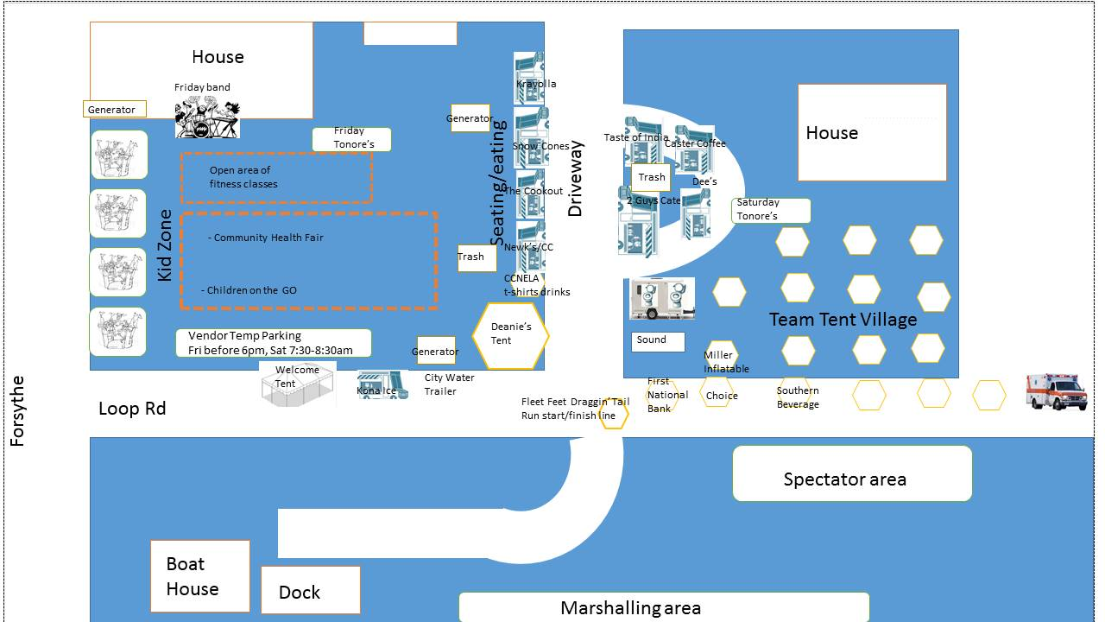

**Cypress Behavioral Health**

**TEAM ROSTER (ReQUIRED at the time of the first practice)** Team: ____________________________________

|  |  |  |  |
| --- | --- | --- | --- |
| **Paddler** | **First Name** | **Last Name** | **Turned in Waiver (Y)** |
| 1 |  |  |  |
| 2 |  |  |  |
| 3 |  |  |  |
| 4 |  |  |  |
| 5 |  |  |  |
| 6 |  |  |  |
| 7 |  |  |  |
| 8 |  |  |  |
| 9 |  |  |  |
| 10 |  |  |  |
| 11 |  |  |  |
| 12 |  |  |  |
| 13 |  |  |  |
| 14 |  |  |  |
| 15 |  |  |  |
| 16 |  |  |  |
| 17 |  |  |  |
| 18 |  |  |  |
| 19 |  |  |  |
| 20 |  |  |  |
| 21 - Drummer |  |  |  |
| 22 - Sub |  |  |  |
| 23 - Sub |  |  |  |
| 24 - Sub |  |  |  |
| 25 - Sub |  |  |  |

**CONTACT & WAIVER FORM- Each participant must complete BY SIGNING THIS FORM YOU ARE WAIVING IMPORTANT LEGAL RIGHTS \*\*\**PLEASE READ CAREFULLY THIS FORM\*\*\** ReQUIRED at the first practice.**

1. This Waiver covers my participation in any events involving dragon boat racing/practicing/instruction, or dry-land training exercises where the Bayou DeSiard Dragon Boat Festival is involved.
2. Participating in the above activities involve risks, dangers and hazards. For example, a boat could capsize or boats could collide in good or bad weather. An approved personal flotation device ("PFD") is required to be worn by all participants at all times while on the water and will be provided by the Bayou DeSiard Dragon Boat Festival. I am aware that by participating in the above activities I am risking personal injury, death, or damage to property. I accept and assume those risks.
3. I release the following companies and people: 22DRAGONS, Children’s Coalition for Northeast Louisiana, Property Owners - Guy Campbell, Tom and Deanie Baker, Sponsors and Vendors, including First National Bank, Choice Brands, Southern Beverages, Tonores Wine Cellar, Fleet Feet, and the directors, officers, employees, agents, independent contractors and volunteers any of the above (all of whom are referred to as the Releasees in this Waiver Form), from any and all liability for any loss, damage, injury or expenses that I may suffer as a result of my participation in the activity above, no matter how caused, including if caused by the negligence of any of the Releasees.
4. If someone sues me for negligence, I agree not to claim contribution or indemnity from any of the Releasees. I release the Releasees from all liability that could arise from such a contribution or indemnity claim.
5. I agree to hold harmless and indemnify the Releasees in respect of any claims, liability or legal expenses that they incur arising directly or indirectly by reason of a claim brought by me against any person or entity for loss, damage, injury or expenses suffered by me. For example, if I sue a member of another team or my coach or a steersperson for negligence, and that person in turn claims contribution or indemnity from 22DRAGONS, then I am agreeing to pay 22DRAGONS for all liability claims and legal expenses that it incurs in connection with the contribution and indemnity claim.
6. I confirm that I have attained the age of 18 years or if not, my parent or guardian has signed this Waiver.
7. I recognize and agree that I am not allowed to participate in the activity above unless I sign this Waiver. I agree that this Waiver is binding on me and on my heirs, executors, administrators and legal representatives.

**TEAM NAME**

**Last Name, First Name**

**Address** (N°, Streeet, apt., City, ZIP)

**Email Phone/Cell Phone Date of Birth**

do you have a **medical condition** our staff should be aware of **(specified)?**

**Contact person in case of an emergency Phone number** to contact this person

**Signature Date**

**Signature of Parent/guardian (if under 18) Date**

I want to be connected! - Please have the Children’s Coalition send me information and newsletters.

FLEET FEET DRAGGIN’ TAIL 5K FUN RUN

Join us Friday, May 11 for a dusk 5K run on the bayou to kick off the Bayou DeSiard Dragon Boat Festival—Draggin’ Tail Run—and then stay for the "Dotting the Eye" VIP party   
•$15 ages 12 & up   
•$25 for family ages 12 & up (no limit to family member #)   
•$0 Children’s Coalition CURRENT & NEW members. Join the Coalition Today for free race registration!

**VIP Party Pass/Fun Run Packet pick up** – Thursday, May 10 12-6 p.m. Friday, May 11 10-3 p.m. Fleet Feet   
1866 Forsythe Ave., Monroe, LA

**Register online**:  [https://legacy.imathlete.com/events/draggintail](https://www.google.com/url?q=https%3A%2F%2Flegacy.imathlete.com%2Fevents%2Fdraggintail&sa=D&usd=2&usg=AFQjCNEQczBS5v6YcEVZzzzB3m1lXM2Q2A) **or complete the registration form**:

